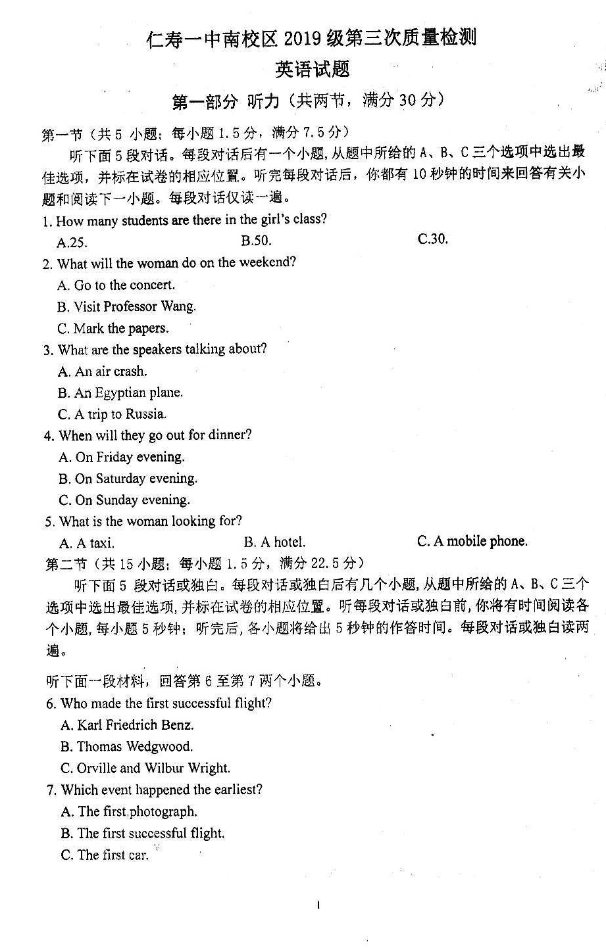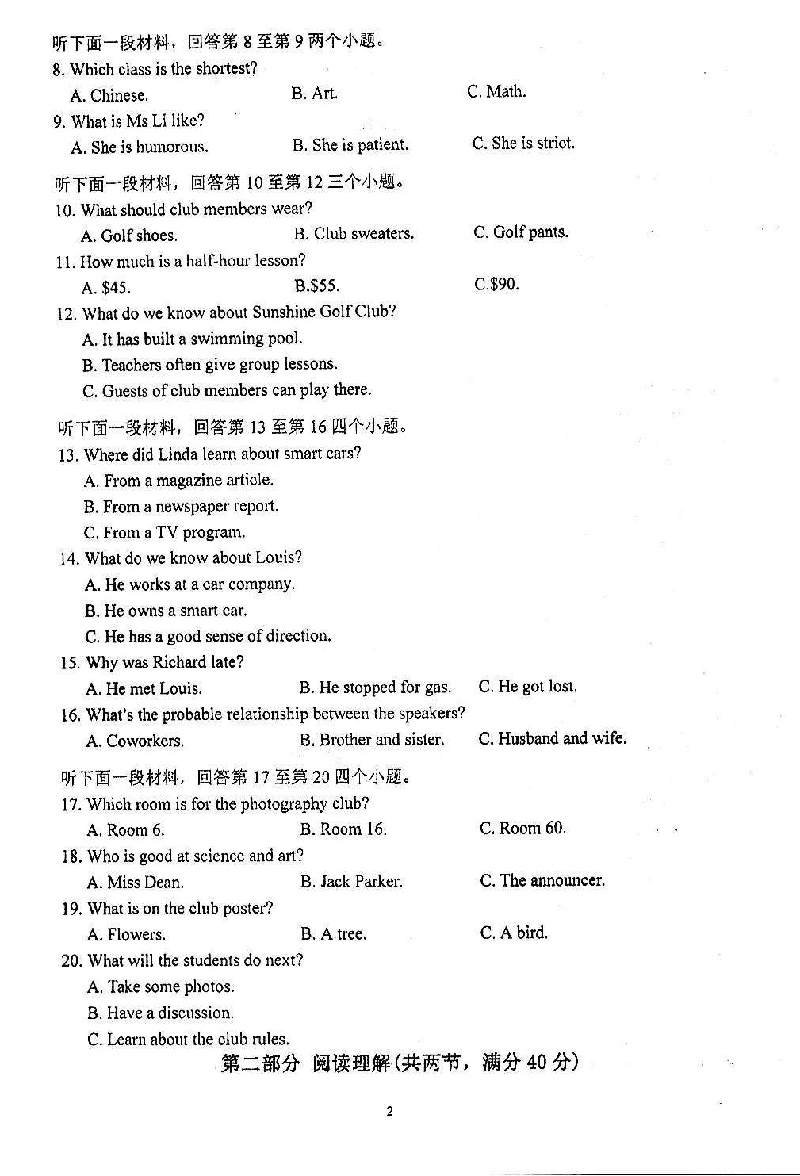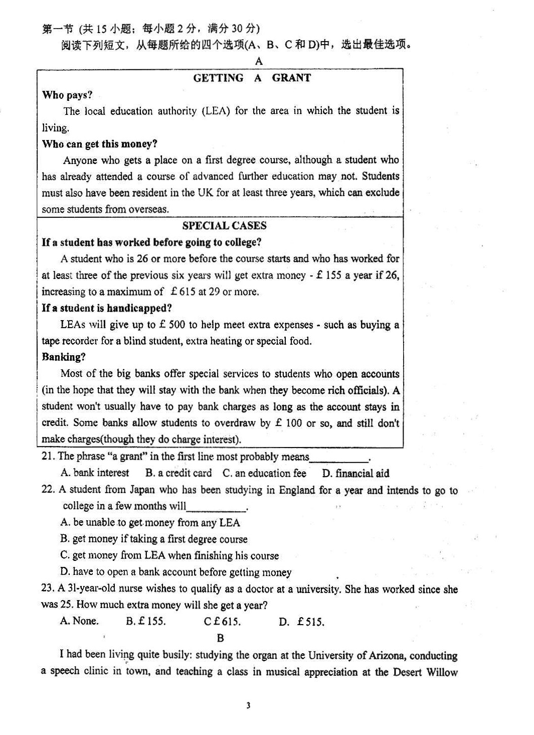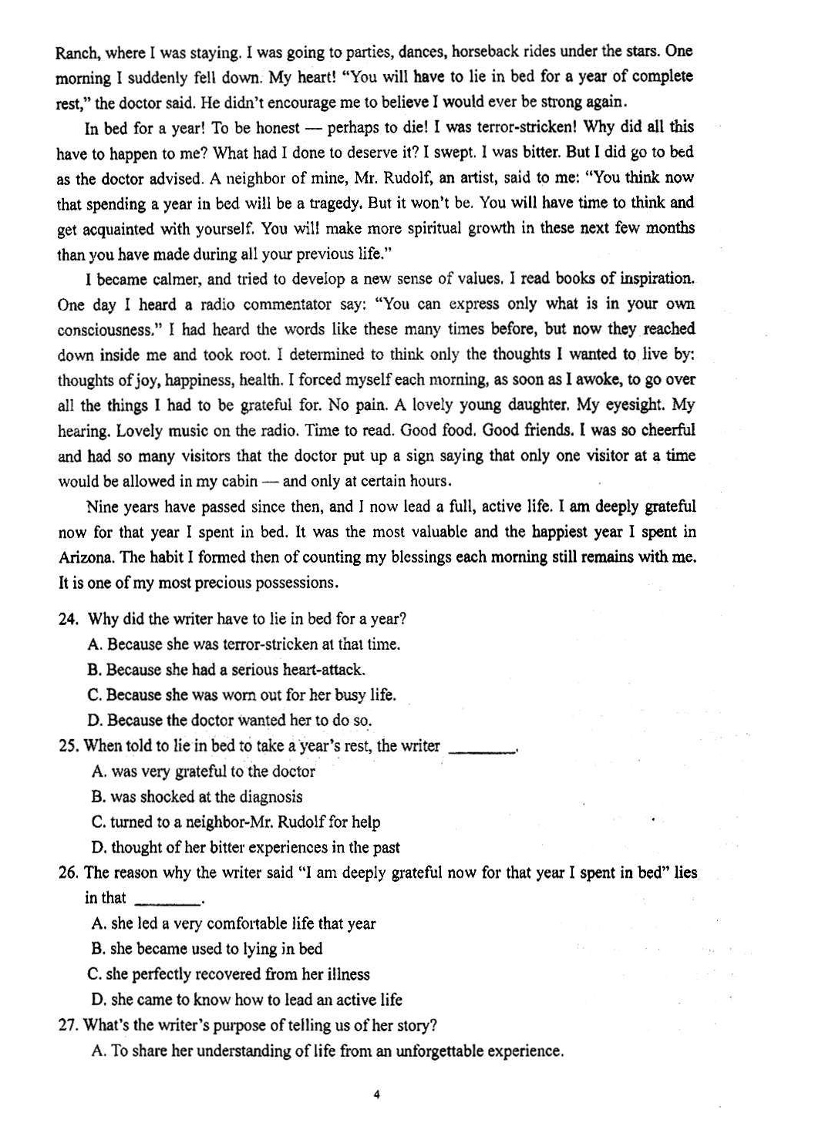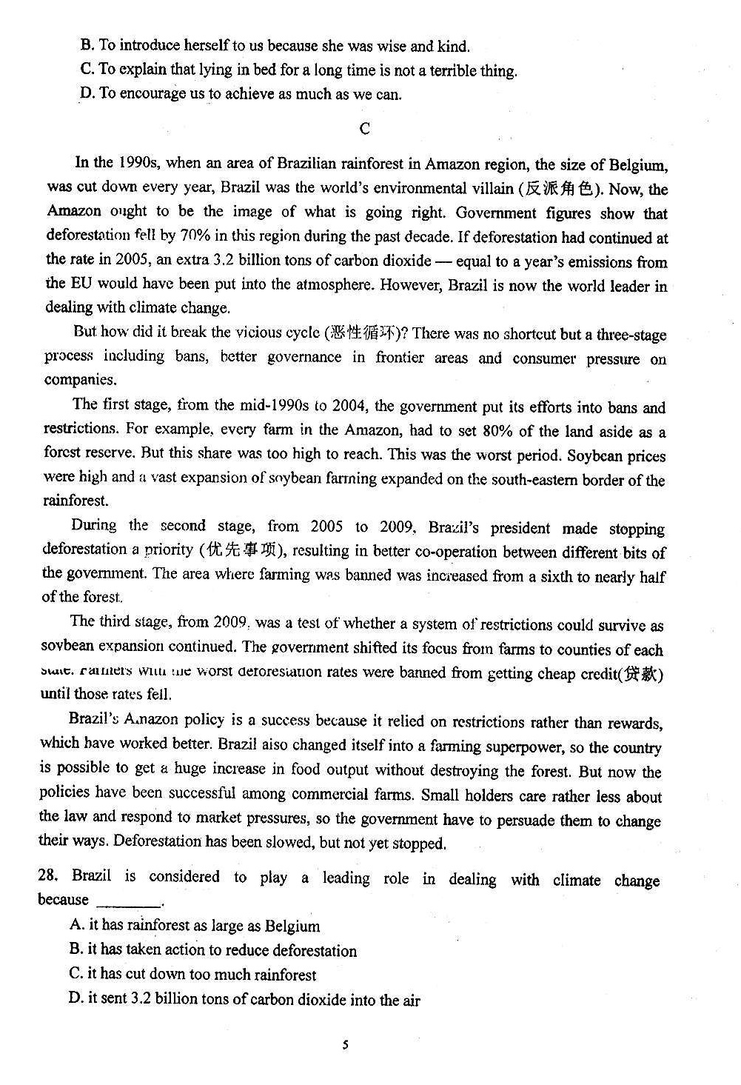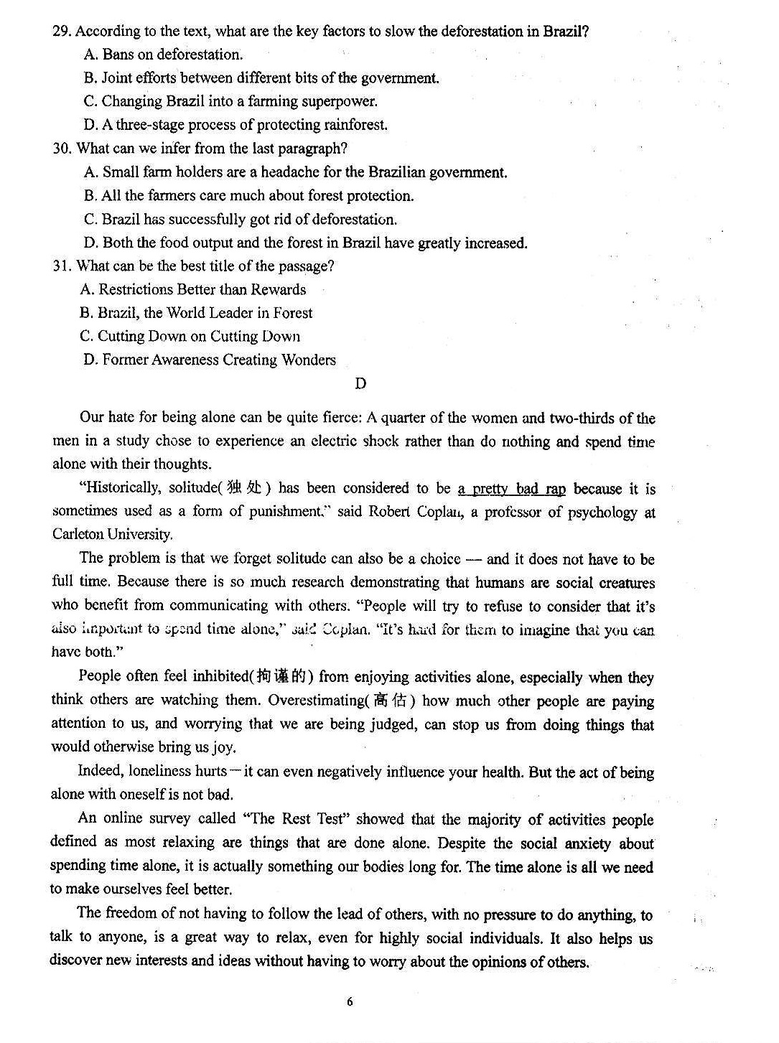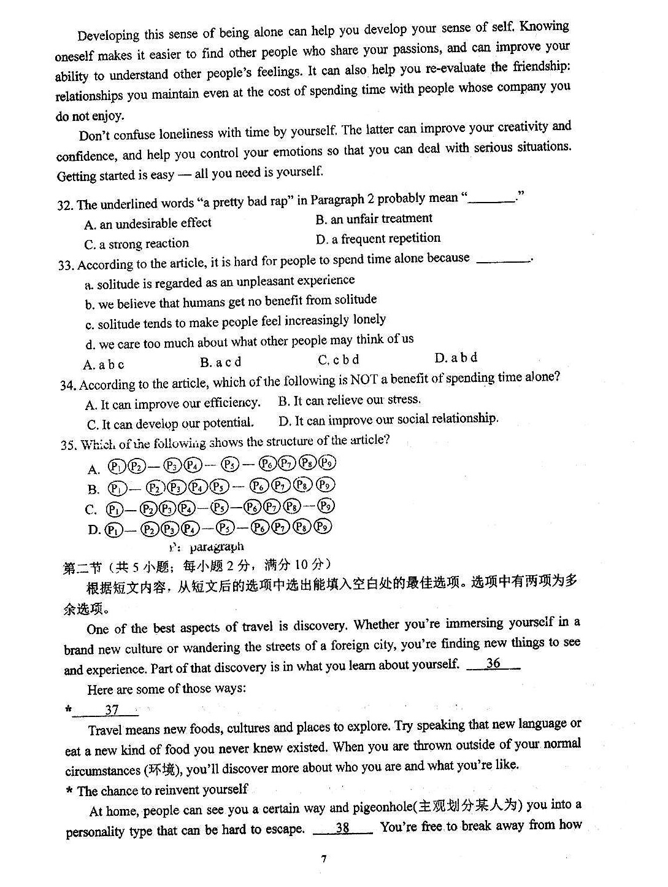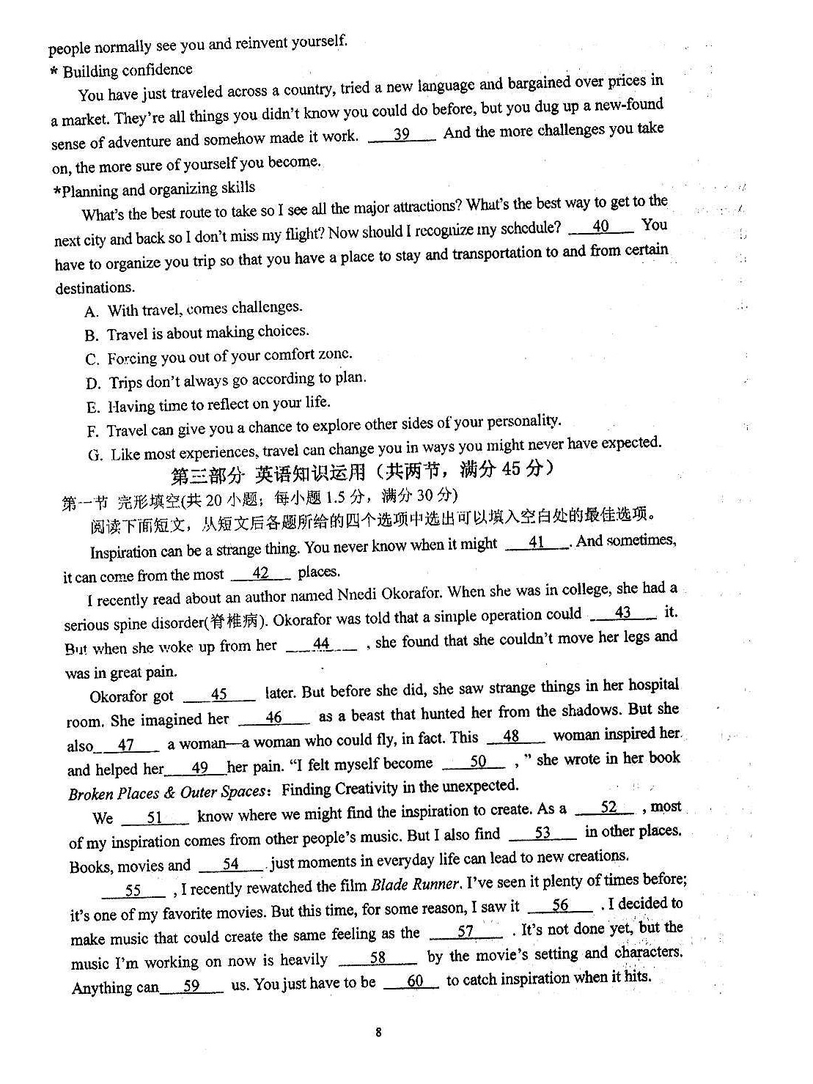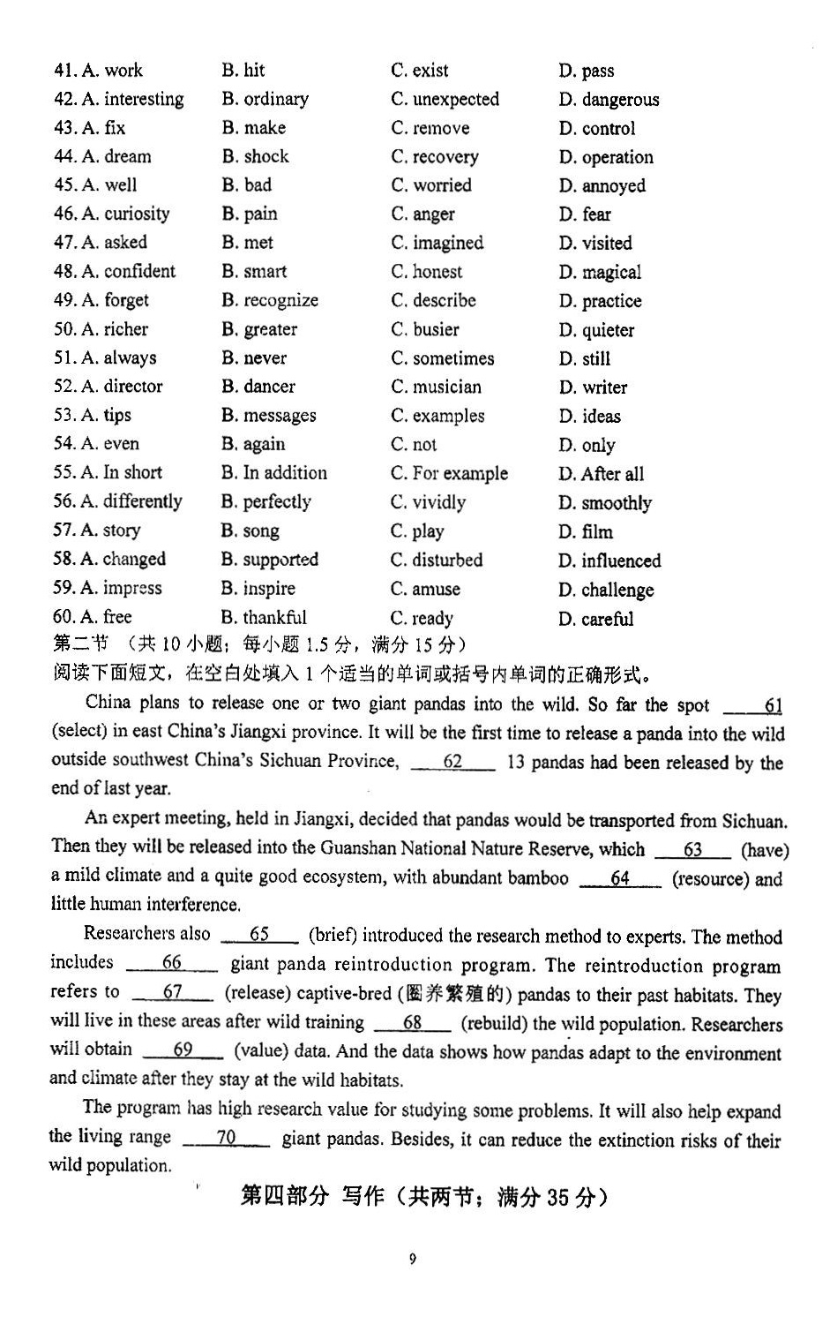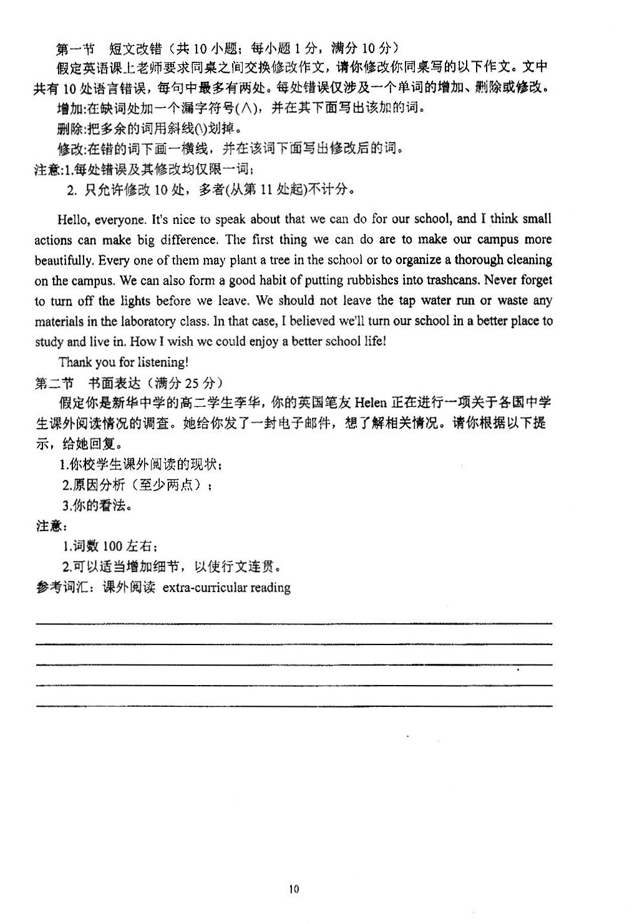

英语试题参考答案
听力
1. B 2. C 3. A 4. B 5. C 6. C 7. A 8. B 9. A 10. A
11. B 12. C 13. A 14. C 15. B 16. A 17. B 18. A 19. C 20. C
阅读理解
21. D 22. A 23. C 24. C 25. B 26. D 27. A 28. B 29. D 30. A
31. C 32. B 33. D 34. A 35. D 36. G 37. C 38. F 39. A 40. B
完形填空
41. B 42. C 43. A 44. D 45. A 46. B 47. C 48. D 49. A 50. B
51. B 52. C 53. D 54.A 55. C 56. A 57. D 58. D 59. B 60. C
语法填空
61. has been selected 62. where 63. has 64. resources 65. briefly
66.a 67. releasing 68. to rebuild 69. valuable 70. of

短文改错
Hello, everyone. It's nice to speak about that we can do for our school, and I think small
what
actions can make∧big difference. The first thing we can do are to make our campus more
a is
beautifully. Every one of them may plant a tree in the school or to organize a thorough cleaning on
beautiful us
the campus. We can also form a good habit of putting rubbishes into trashcans. Never forget to
rubbish
turn off the lights before we leave. We should not leave the tap water run or waste any materials in
running
the laboratory class. In that case, I believed we’ll turn our school in a better place to study and live
believe into
in. How I wish we could enjoy a better school life!
Thank you for listening!
书面表达(One possible version)
Dear Helen,
I’m more than happy to receive your email, asking me about the extra-curricular reading in our school. I’m willing to share something about it. Regrettably, most of us don’t devote our time to extra-curricular reading and even if we do so, the variety of the books is limited.
I think the reasons behind that are various. First, many students are burdened with too much academic studying. Second, some students haven't formed a habit of reading but spend time chatting or playing games on the Internet.
However, reading has many benefits. It can help us learn more about the world and enrich our life. So it’s necessary for us students to take up reading as a good habit.
Best Wishes! (119 words)
Yours,
Li Hua

书面表达评分细则
一、各档次语言要点评分参考标准
档次 | 要点数 | 要点分 | 语言要点表达情况划档依据
第五档 | 5 | 21-25 | 语言基本无误，行文连贯，表达清楚
第四档 | 4 | 16-20 | 语言有少量错误，行文连贯，表达基本清楚
第三档 | 3 | 11-15 | 语言有一些错误，尚能表达
第二档 | 2 | 6-10 | 语言错误很多，影响表达
第一档 | 1 | 0-5 | 只能写出与要求内容有关的一些单词
二、内容要点认定及计分参考标准
1. 恰当的开头和结尾（阐述清楚，表达正确，计3分）
2. 写信目的（阐述清楚，表达正确，计3分）
3. 课外阅读的现状（阐述清楚，表达正确，计4分）
4. 两点原因（阐述清楚，表达正确，计8分）
5. 你的看法（阐述清楚，表达正确，计5分）
6. 邮件格式（阐述清楚，表达正确，计2分）
三、扣分参考依据
1. 其表达未能达成正确句意的，不给分。如：写出了主语或谓语等关键词，但未能达成符合要点要求，意义正确的句子。
2. 句子结构完整，但关键点出现错误或漏掉部分关键词，扣半个要点分。如：主谓一致错误，或关键词拼写错误，或谓语动词时态、语态错误等。
3. 凡使用铅笔答题，或答题中使用了涂改液或不干胶条，一律不给分。
4. 凡多次出现非关键性单词拼写错误或其它同类错误，原则上每四处扣1分。
5. 文章内容要点全面，但写出了一些多余内容，原则上不扣分。
6. 凡书写超出规定的答题区域，全卷不给分。
7. 书写潦草凌乱，但基本不影响阅卷的，酌情扣卷面分1～2分。
8. 字数少于80或多于120的，在总分中减去2分。

眉山市高中2021届第四学期期末教学质量监测
听力录音材料
Text 1
M: How many of you have joined the sports club?
W: Twenty-five. That is half of the students in my class.
Text 2
M: Would you like to go to the concert with me this weekend?
W: I’d like to, but I’ve promised Professor Wang I would mark all these papers by Monday.
Text 3
W: Have you heard about the Russian plane crash in Egypt?
M: Yes, it’s terrible. 224 people lost their lives.
W: What a tragedy! To be honest, I always feel a little nervous when I travel by plane.
Text 4
W: Did you finish your homework this afternoon?
M: Sorry, Mum, I didn’t. But I’ll do it tonight.
W: But we are going out for dinner with grandpa.
M: Then I’ll do it tomorrow morning. It will be Sunday so there will be enough time.
Text 5
M: Do you remember how you lost your mobile phone?
W: After the conference, I went back to my hotel. Perhaps I left it in the taxi when I got out.
M: Why not contact the taxi company to find out whether they have it.
Text 6
W: Do you know when the car was invented?
M: About 130 years ago. The first car was invented by Karl Friedrich Benz in 1885.
W: Do you know who made the first successful flight? And when was it?
M: Yeah. Orville and Wilbur Wright, two brothers, made it in 1903.
W: When did people start taking photographs?
M: About 220 years ago. Thomas Wedgwood made the first photograph on glass in 1802.
W: That is such a long time ago!
Text 7
M: Mary, you are back. How was your first day of school?
W: It was great.
M: What classes did you have?
W: I had Chinese from 8:30 am to 10 am, art from 10:30 am to 11:30 am and math from 3 pm
to 4:30 pm.
M: I see. What about your Chinese teacher Ms Li?
W: She is funny and always makes us laugh in class.
M: I see. Did she give you any homework?
W: No, she said she wanted us to relax tonight.
M: No wonder you like the teacher so much.
Text 8
W: Sunshine Golf Club, how can I help you?
M: I’d like some information about the club, please.
W: Right now we only have one club area, but we’re building another new one with a swimming
pool. It will open next year.
M: Do members have to wear special clothes at the club?
W: Unlike many other clubs, you don’t have to wear golf pants or club sweaters. However, members have to play in proper golf shoes
M: Right. How about lessons for children? Do you have group lessons?
W: Our teachers don’t give group lessons. A one-hour lesson costs $90, but that’s usually too long for kids. That’s why our teachers only give half-hour lessons, for $55 each kid.
M: Hmm. Can visitors play here?
W: Yes, but you must be the guest of one of our members.
Text 9
M: Hi, Linda! Sorry I’m late.
W: Richard! Good to see you. Don’t worry about it. You’re the first person of our office to
arrive. My house is difficult to find. But if you had a smart car, it was much easier.
M: A smart car? What’s that?
W: I just read an article from a magazine about them. They have GPS with a map and voice built in. You just enter the address and the voice will tell you how to get there.
M: Wow, that sounds just like my brother, Louis. He never gets lost, and he’s always telling me the best route. So, what else can smart cars do?
W: They are equipped with warning systems to ensure drivers’ safety.
M: Amazing. Are these cars smart enough to fill themselves up with gas? W: Not that I know of. Why?
M: I didn’t get lost on the way here. But filling up my car costs me too much time.
Text 10
M: Boys and girls, welcome to this first meeting of the photography club. It’s good to see so any of you. I’m glad you got the information about the room change. Room 6 isn’t big enough for us all! Remember, this will be our room for the term: room 16. I know five people from last year, but I think everyone else is new. There are some people here to help you. We have Miss Dean—some of you have lessons with her. She is our favorite science teacher. Miss Dean is an art lover, and she’s very good with a camera. She’s won lots of competitions. We’ve also got Jack Parker with us. You know him from sports lessons! Jack is a real expert. He is good at taking photos of flowers, trees and birds. He took the photo for our club poster—a flying bird. He and Miss Dean are here to give advice on how to create best photos. That’s enough from me. Now, Miss Dean will tell you the basic rules of the club. Let’s welcome Miss Dean.

