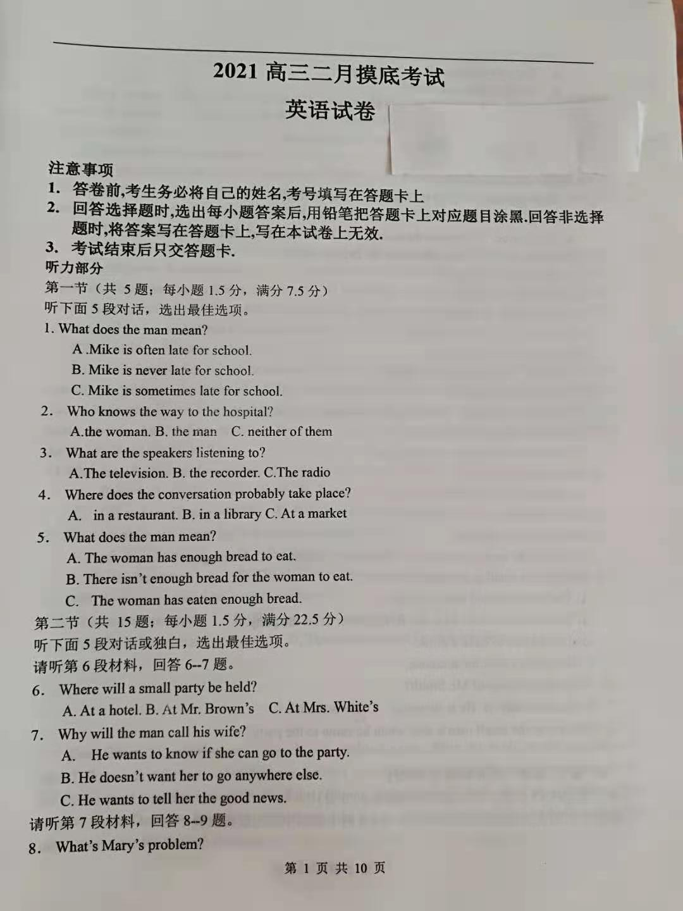

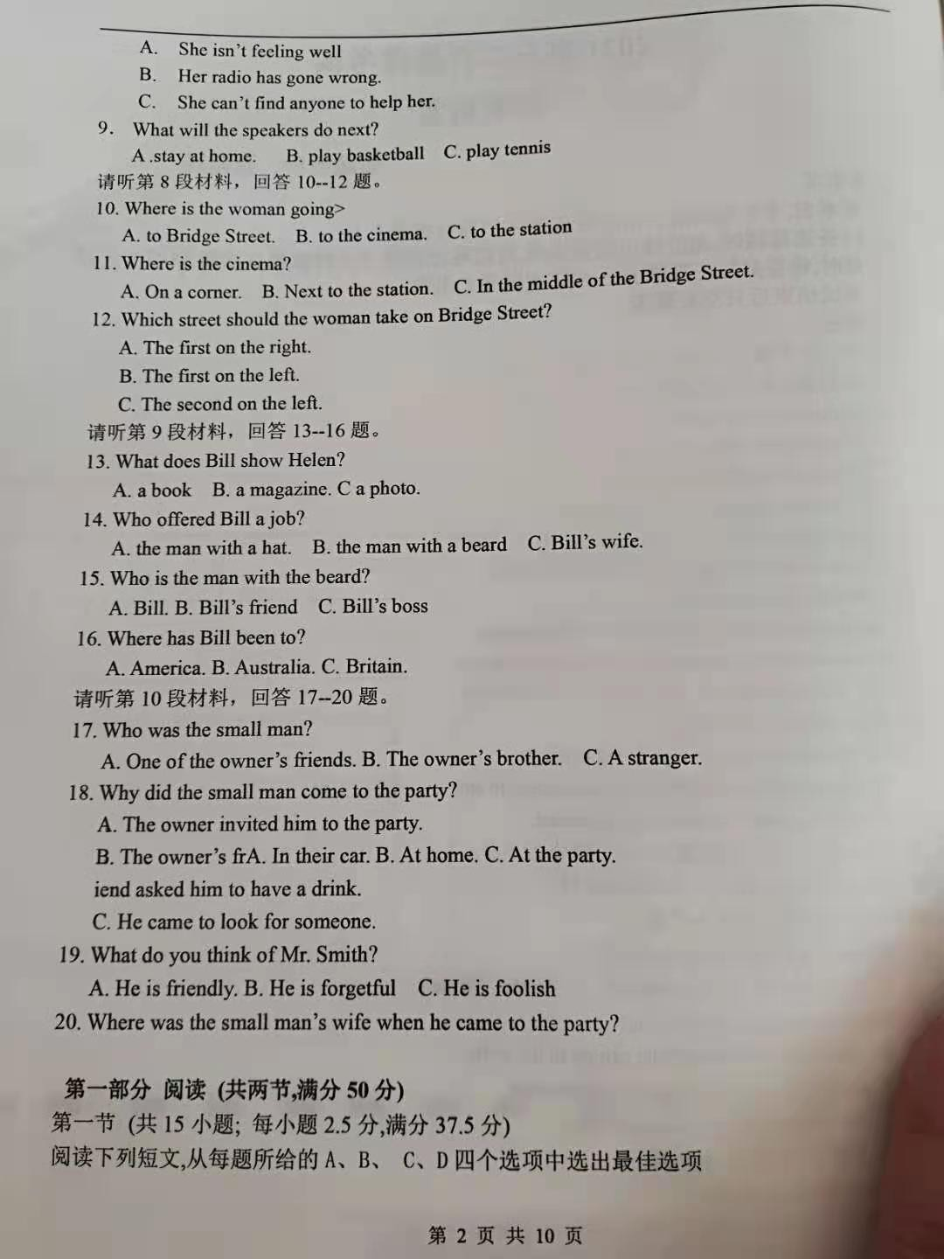

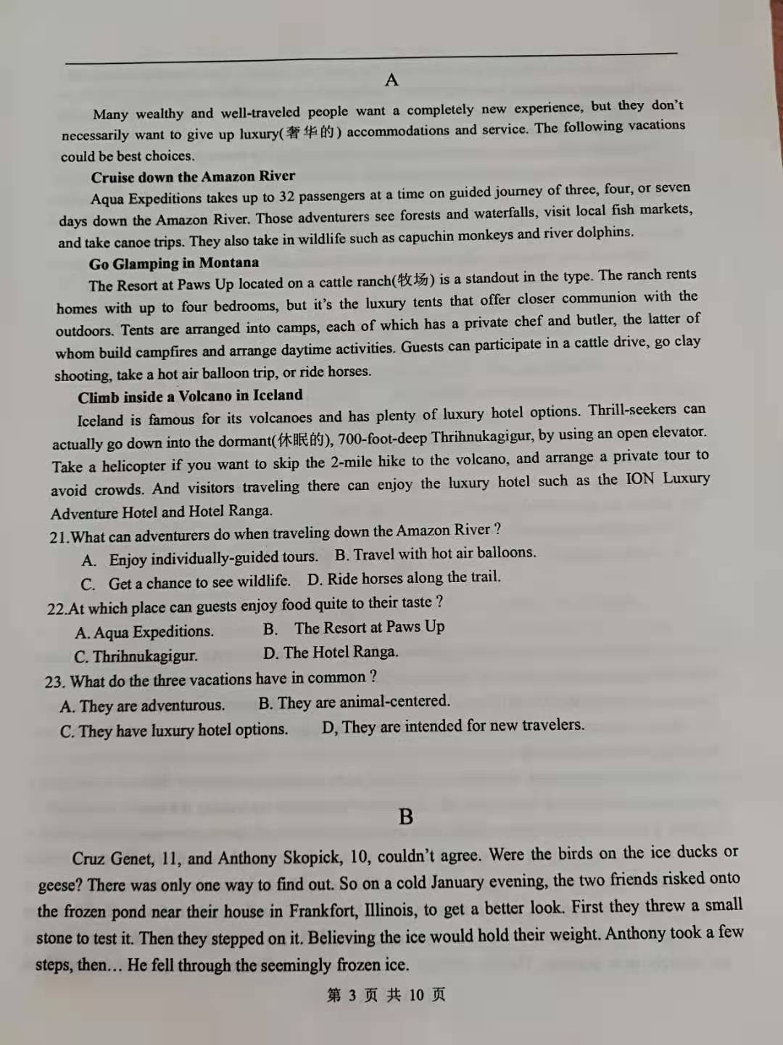

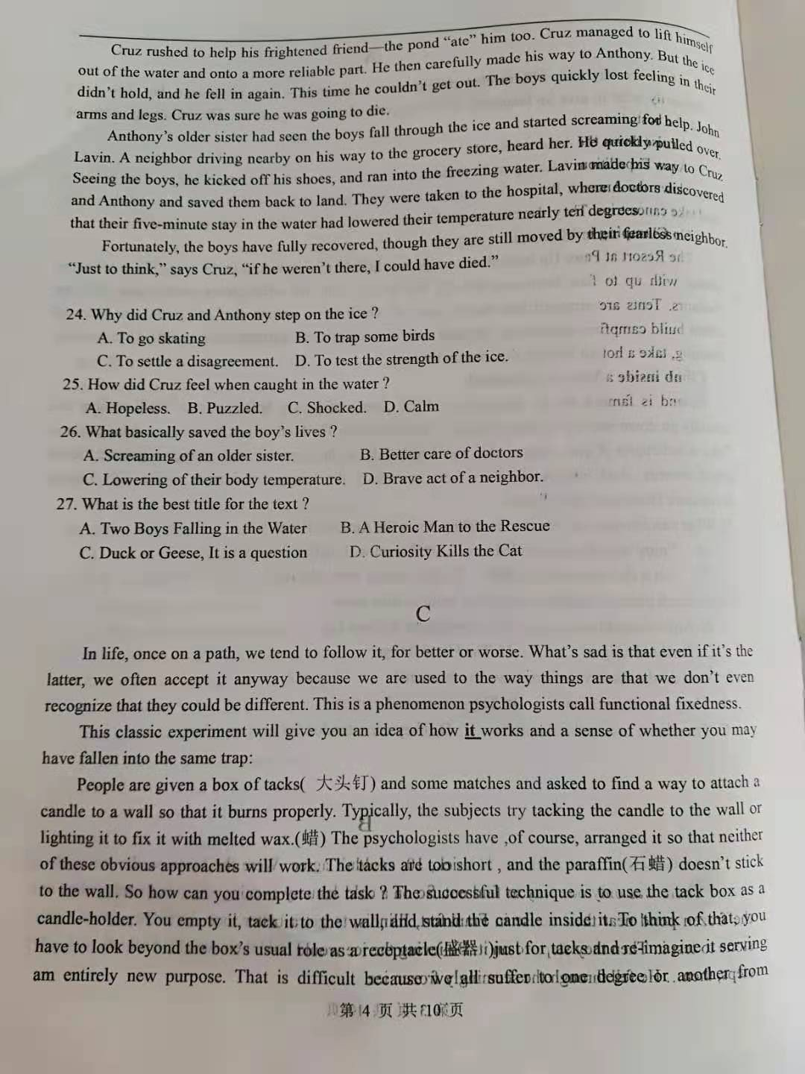

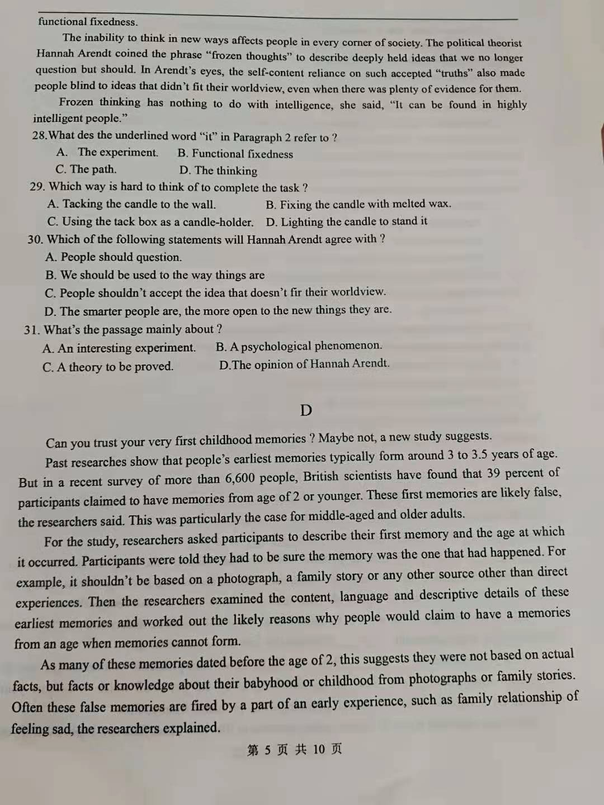

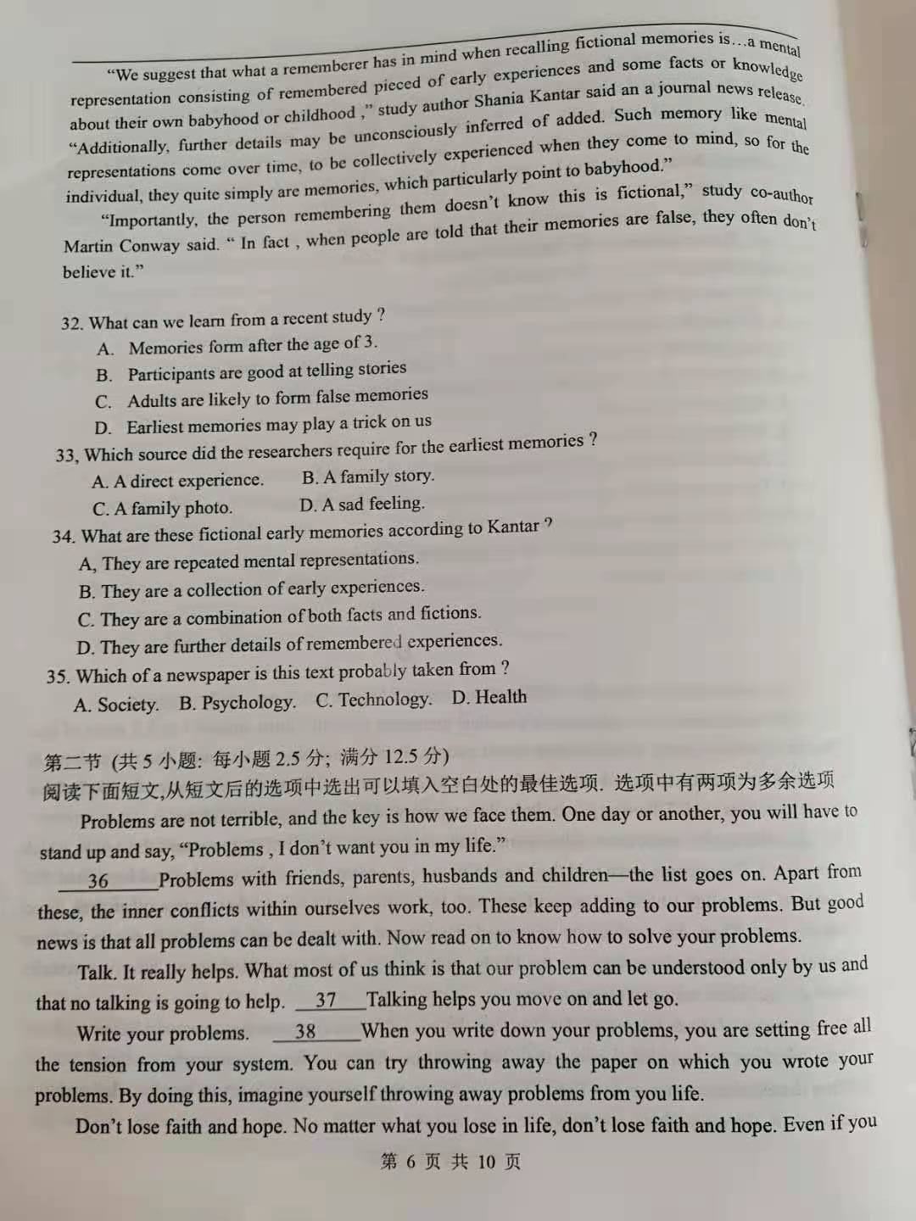

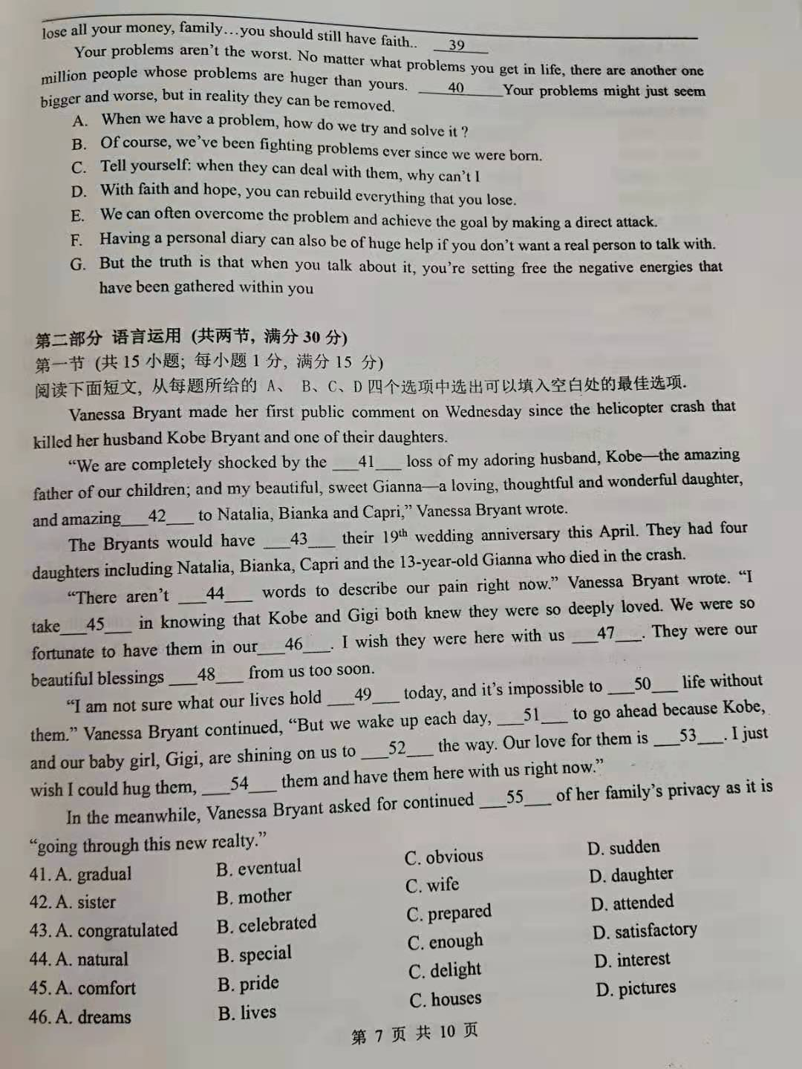

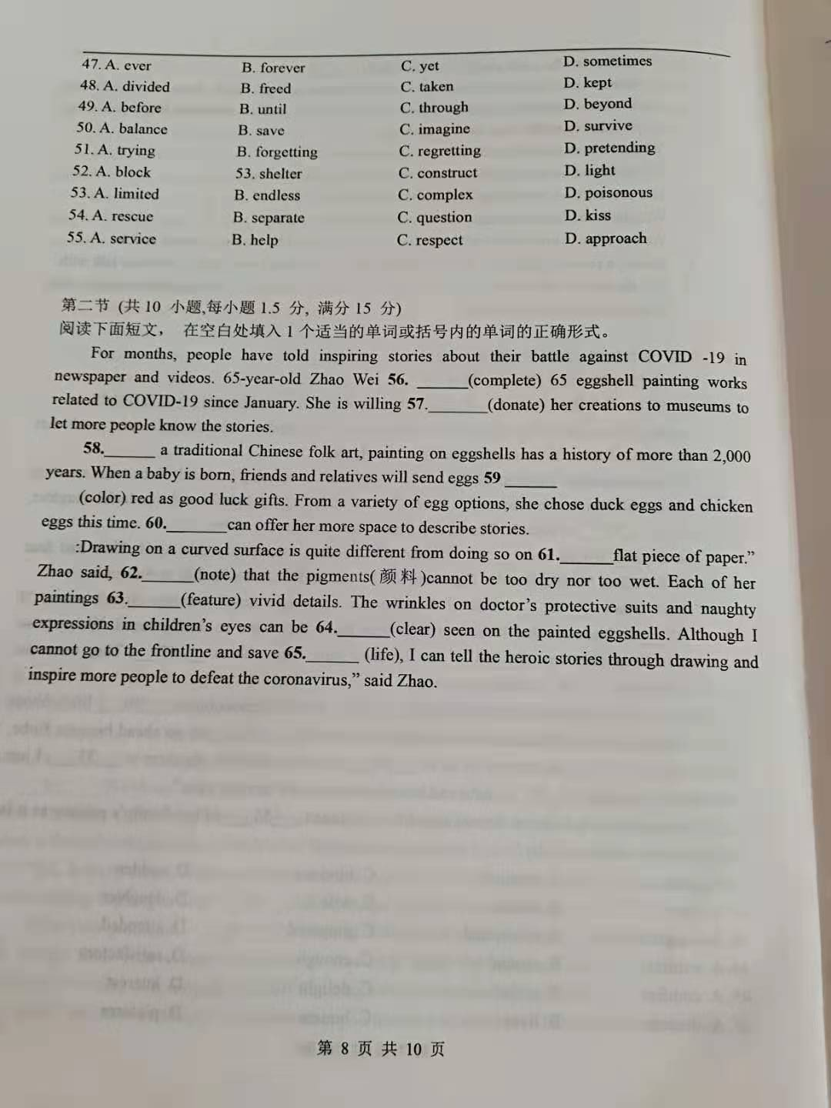

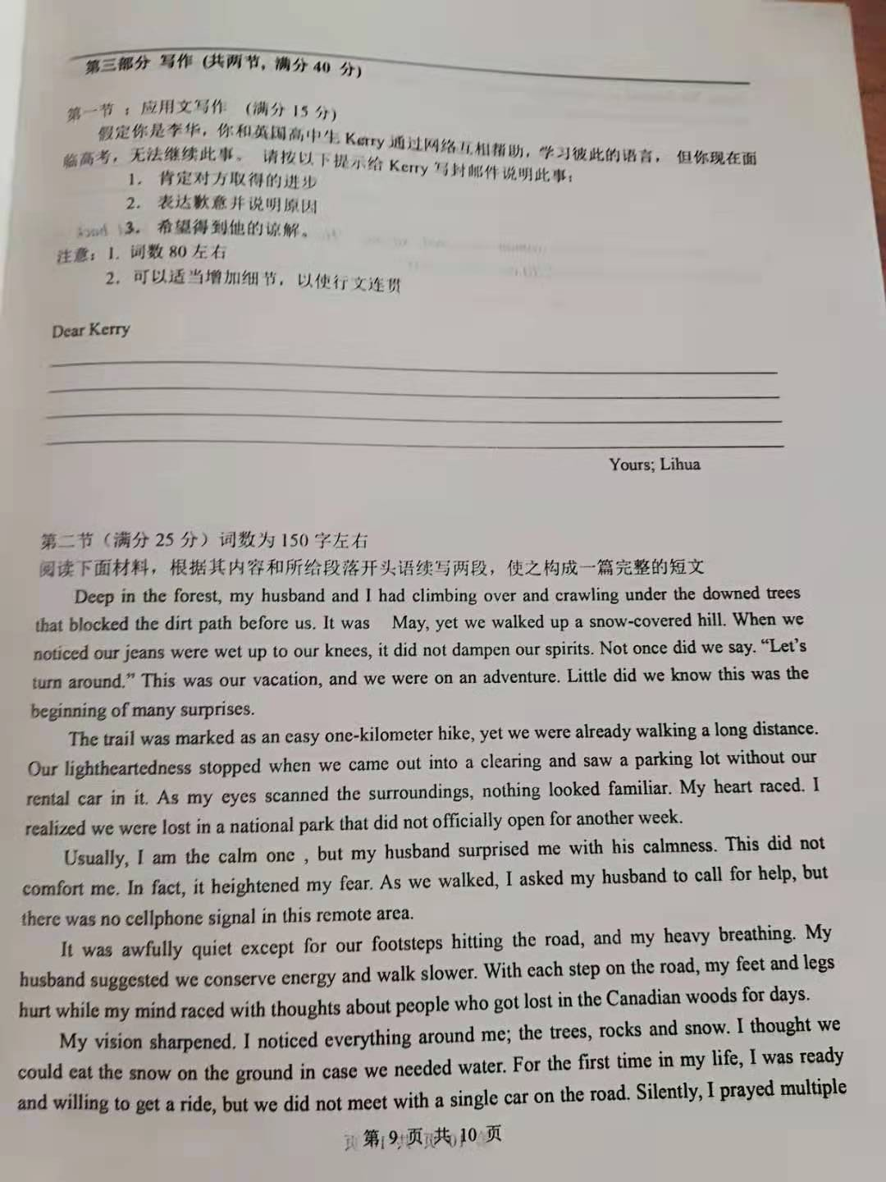

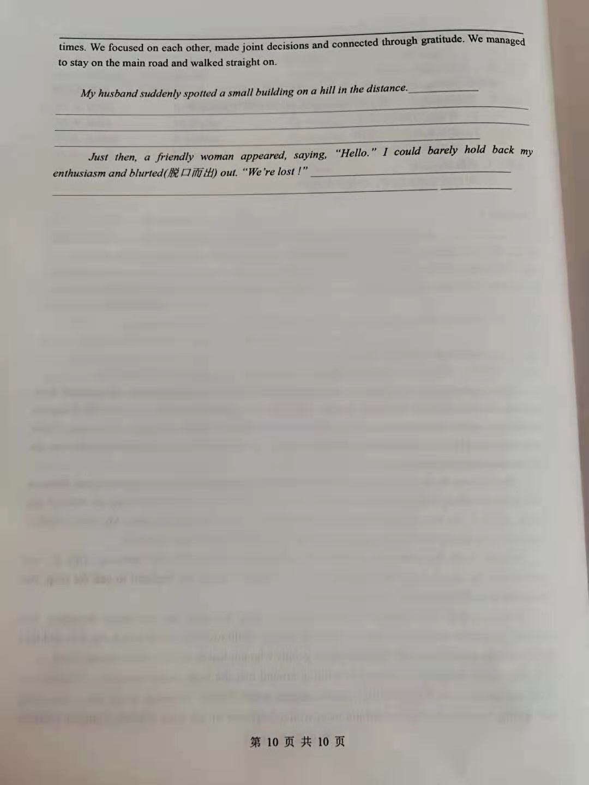
2021二月摸底考试答案
21—23 CBA 24---27 CADB 28---31 BCAB 32---35 D A C B
36---40 BGFDChich
41---55 DABCA BBCDC ADBDC
56.has completed 57. to donate 58. As 59. colored 60.They 61. a 62. noting
63. features 64. clearly 65. lives

应用文参考
Dear Kerry.
I am really sorry that I have no choice but to stop our online language learning for a while. Words fail me to convey my deep regret.
Due to hard work, you have made much progress in Chinese, so have I in English. But faced with a significant challenge---the College Entrance Examination, I will devote myself to my study and have no time to surf the Internet. I promise I’ll spare no effort to help you with your Chinese learning after the exam.I would be grateful if you could understand and forgive me.
Looking forward to studying with you online soon.

续写参考答案
My husband suddenly spotted a small building on a hill in the distance. In no time we found ourselves heading for it. We were filled with hope and excitement to find such a building in the middle of nowhere. We climbed up the hill at a swinging pace as if all the pains were gone. As we approached, a sign came into sight, which read: Administration Office. However, it was not open for business. The empty hall made us nervous all at once. We stood there hopelessly wondering what to do next.
Just then, a friendly woman appeared, saying, “Hello.” I could barely hold back my enthusiasm and blurted(脱口而出) out. “We’re lost !” She comforted us and opened a room for us to take a break. Seeing we were cold and hungry, she treated us with hot chocolate. After studying the map, we figured out that our car was parked over three kilometers away. She offered us a ride back to our car and we accepted gladly. I felt relieved to see our rental car again. What a blessing to have such an unforgettable experienc

