呼和浩特市2018届高三年级质量普查调研考试
英语
第二部分 阅读理解（共两节，满分40分）
第一节：（共15小题；每小题2分，满分30分）
阅读下列短文，从每题所给的四个选项（A、B、C、和D）中，选出最佳选项，并在答题卡上将该项涂黑。
A
Where Is Spring Break
Where is Spring Break going to be? The options are endless. Do you want to get your blood pumping from thrilling travels? Look no further! These tours and destinations will keep you on your toes all week long.
Panama: This underrated destination is a little-known secret of the most travelers! Through this tour you’ll get to hike, snorkel (浮潜) and explore all the best sights this beautiful country has to offer! Eight days tours for $ 250 / day.
Canada: This diverse country is full of options. Explore the East of Canada and visit cities such as Montreal, Quebec or Toronto. If you’re feeling adventurous, explore the Western part of the country with a Canadian Rockies Tour. During this twelve days tour you will hike a glacier to beautiful scenery and wander through postcard-worthy villages. Tours to Canada for $ 200 / day.
Iceland: Check off one of the seven wonders of the world with a tour of the Northern Lights and Golden Circle. Spend seven days full of adventure like hiking glaciers, snowshoeing through Thingvellir National Park, relaxing in the Geysir Hot brings and of course experiencing the glory of the Northern Lights! Seven days tours for $ 300 / day.
South Africa: Discover the diverse culture and wildlife that makes up South Africa. Your tour plan includes a journey along the coast known as “Rainbow Nation.” Here you will enjoy beautiful scenery, a hunting travel through Addo Elephant National Park and the wildlife in Tsitsikamma National Park. Nine days tours for $ 230 / day.
21. What is the common characteristic of the travels mentioned in the text? A. Exciting. B. Risky. C. Educational. D. Environmental
22. According to the text, Panama is a destination which___ .
A. is not as famous as the other three
B. you can go to for enjoying surfing
C. offers an option to hike in the park
D. takes the most time of the four tours
23. Which destination costs tourists the most money?
A. Panama. Africa. B. Canada. C. Iceland. D. South Africa
24. What can be learned from the text?
A. Tourists can take a hot shower only in Iceland.
B. Tourists can hike glaciers in both Canada and Iceland.
C. Canada offers Rockies Tour for tourists to explore the East.
D. Tourists can enjoy a hunting travel through Tsitsikamma National Park.
答案：21-24 AABB
解析：
- 细节题。由第一段“Do you want to get your blood pumping from thrilling travels? ”可知，所有以下的度假地应该是“令人激动的”。
- 细节题。由第二段“Panama: This underrated destination is a little-known secret of the most travelers!”可知，它是一个(little-known)鲜为人知的度假地。
- 推断题。通过计算可知，Canada花费最多，12200=2400.
- 推断题。 通过“During this twelve days tour you will hike a glacier to beautiful scenery”“Spend seven days full of adventure like hiking glaciers”,第三段和第四段这两个句子可知，选B.
B
When Hai started college, he weighed over 250 pounds. Healthy food choices were difficult for him, and he was emotionally distraught (忧心忡忡). However, when he left home for college, he was able for the first time to start taking his life and weight into his own hands.
He started by shopping at a local farmers’ market, an experience that inspired him profoundly. The idea that a farmer’s market represents local, sustainable, healthy food with a human connection where you can interact with the people that grow your produce was extremely appealing to him, and he began to think about the food that people at his university were eating. From what he saw at farmers’ markets, Hai realized that dining hall food was not “real” food. A lot of it is frozen or processed, and has unhealthy additives. His ideas continued to develop as he started taking classes about food sustainability at university, and after the summer of 2014 during which he cooperated with other students, he launched into his senior year at the University of California full force with the Real Food Challenge (RFC) campaign, a project he co-founded that aims to reinvest university spending in food that is “real”: ecologically-sound, community-based, humane, and fair; as opposed to those traditional purchases with those unhealthy additives and processed products.
Not only has Hai started a movement of change across the university dining system, but he has also grown extremely as an individual, now with strong leadership abilities and great vision. In addition, after he started learning about food sustainability and taking action at university, Hai has lost over 100 pounds, and has been able to start enjoying activities such as backpacking and swimming that were not a possibility for him previously. He is confident instead of distraught now.
25. When did Hai get the idea of “real” food?
A. When purchasing the locally-made food.
B. When reforming the university dining system.
C. When reinvesting university spending in food.
D. When organizing the Real Food Challenge campaign.
26. What benefit has the campaign brought to Hai’s occupational development?
A. He has been hired by the university.

B. He has become an expert in food field.

C. He has got excellent leading ability.

D. He has become much thinner than before.

- According to Hai, "real" food is .
A. rich in nutrition B. made by experts
C. frozen or processed D. healthy without additives

答案：25-27ACD
解析：
- 细节题。由第二段第一二句话可知，应该选A。
- 细节题。由最后一段“Not only has Hai started a movement of change across the university dining system, but he has also grown extremely as an individual, now with strong leadership abilities and great vision. ”可知选C。
- 细节题。由倒数第二段的倒数第一句可知应该是没有添加剂的健康食物。
C
Feifei, an 11 -year-old boy from Xuzhou, Jiangsu Province, suffered from a sudden acute eye disease which has almost led to blindness. The disease was caused by excessive (过度的) eye fatigue (疲劳) during the winter vacation, during which he played computer games for continuous 10 days and nights.
Many youngsters in China nowadays are increasingly addicted to computer games and other electronic products. This is followed by a series of health problems,with the most typical case being myopia, or nearsightedness.
According to the latest research report released by the World Health Organization (WHO), the myopia rate among Chinese teenagers ranks first in the world—70 percent of high school and college students. The rate is nearly 40 percent in primary school students, while it is only 10 percent for their peers in the United States.
There are at least 10 million people in China with severe myopia, and they are likely to get pathological (病理性的) myopia in middle age. Pathological myopia can't be treated with glasses or surgery, and it is one of the biggest factors that lead to blindness, Xu Xun, director of the ophthalmology (眼科学 ) department at Shanghai General Hospital, pointed out.
Experts explain that two major factors lead to the high rate of myopia among Chinese people. One is high academic pressure, and the other one is excessive use of electronic devices over a long period of time. Genetics, on the other hand, are not the main reason, as only 20 percent of Chinese people had myopia in the 1960s.
"Teenagers are now faced with severe academic pressure, which means they often study without natural light. This increases their risk of becoming nearsighted," Xu said.
Experts suggest that youngsters maintain a proper balance between study and rest so as to protect their eyesight, and parents should play an active role in the process.

28. Why does the author mention Feifei 's experience in the first paragraph?
A. To advise people to protect their eyes.
B. To introduce the topic of nearsightedness.
C. To inform people of the cause of blindness.
D. To show that Feifei developed an eye disease.
29. What can be learnt from the passage?
A. Nearsightedness may cause other health problems.
B. There are more nearsighted students in the United States.
C. 70 percent Chinese students in primary school are nearsighted.
D. Pathological myopia is most likely to cause blindness.
30. Which of the following can be a main reason for myopia?
A. Genetics factors. B. Low academic pressure.
C. Overuse of electronic devices. D. Reading in natural light.
31. What will be probably discussed in the following paragraph?
A. The significance of protecting eyesight.
B. Youngsters' bad behavior leading to myopia.
C. The relationship between youngsters and their parents.
D. Parents' role in helping youngsters protect their eyesight.
答案：28-31BDCD
解析：
- 推断题。由全文可知，以下都在讲青少年近视的问题，由此推测第一段的例子起到引出下文的作用。
- 推断题。由第四段“Pathological myopia can't be treated with glasses or surgery, and it is one of the biggest factors that lead to blindness, ”可知选D.
- 细节题。由第五段“and the other one is excessive use of electronic devices over a long period of time. ”可知选C.
- 推断题。由最后一段可知选D.

D
Psychology tells us that many people hate to take risks. But it is good for us to take risks, especially when the risk is to achieve a desired result. In that way, we become stronger and braver.
Our human nature should be to take risks, but some people just sit and wish they didn't have the fear to move on. This is because they failed a few times in their lives. Please step out and don't let the past hold you back from living life to the fullest. Move forward and move on! In studying the psychology of taking risks, we find that human provides us with the desire to experiment and take chances.
Risk taking is a great advantage that allowed our ancestors to become stronger and stronger day by day. By taking risks they fought off enemies and discovered new territories. This attitude has become a part of our modern culture. Riding a roller coaster is a common risk taking activity. Even each person seems to enjoy the risk although they have the understanding that it is dangerous. This psychological and biological connection creates an interesting connection between what is unsafe and what humans enjoy.
Getting in a car each day is a risk. Getting out of bed is a risk, too. We need to take risks so that we can complete many things. Astronauts take risks when they get inside a rocket; however, the things they achieve are great. Businessmen take a risk when they buy parts of a company, however, without doing that, they could not make more money.
We need to take risks so that we can gain something. It is impossible to move forward in life, earn money, enjoy a relationship, play a sport, or doing anything else without taking a risk. It is all part of the game. It' s one of the most important parts of life.

32. Some people don' t want to take risks, mainly because .
A. they are too lazy to move on
B. they feel pleased with the present life
C. they have failed several times before
D. they show little interest in the strange world outside
33. What does the underlined part "This attitude" in Paragraph 3 mean?
A. Taking risks
B. Fighting off enemies
C. Discovering new territories.
D. Becoming stronger and stronger
34. What can we infer from the passage?
A. Daily life is full of risks.
B. The safest place has the greatest risk.
C. People should take risks when they are young.
D. We can always achieve our goals by taking risks.
35. What would be the title for the passage?
A. Taking Risks Is Easier Said than Done
B. Risks Taken by Ancestors
C. Live Our Life to the Fullest
D. No Risk, No Gain
答案：32-35CAAD
解析：
- 细节题。由第二段“This is because they failed a few times in their lives.”可知选C.
- 词义猜测题。由第三段第一二句可知，“这种态度”指的是“爱冒险的态度”。
- 推断题。由第四段可知，生活中充满了冒险。
- 主旨大意题。由首尾段及中间段落第一句可知，本文在讲冒险的必要性，因此选D.

第二节 （共5小题，每小题2分，满分10分）
根据短文内容，从短文后的选项中选出能填入空白处的最佳选项，选项中有两项为多余选项。

How to Calm Down at Work
The workplace can be a stressful place. Anxiety, conflict, bad management and
overwork can lead to frustration and stress.36
Keep something you like to look at within sight. A photo of a loved one or a favorite personal souvenir are the best examples. Keep such an item somewhere you can glance at it whenever you wish to do so. 37
Take a moment to engage your body. If you' re unable to leave your work area, stand and stretch for a moment. Muscle tension exercises can also help you calm down. 38 For instance, start by squeezing all of your face muscles as tightly as you can for twenty seconds and slowly releasing them.
Write down the reason why you are upset. 39 Getting your thoughts and feelings out on paper can help clarify the issue you' re having. Writing down your thoughts can even help you determine the best way to address your frustration or anxiety and move forward.
40 If you and another co-worker are constantly frustrated with one another, set up a time to speak with him or her. Say something like, "Hey, Sarah, let' s sit down sometime soon and chat to make sure we' re on the same page about our upcoming project."
- Turn to your workmates for help.
- Communicate with your workmates.
- A vase of flowers on your desk is another good example.
- Focus on one particular muscle or muscle group at a time.
- Here are the steps you can take to help you calm down at work.
- Engage your body by rolling your head, shoulder, and ankles while sitting.
- The best way to figure out exactly what's bothering you is to write it down.
答案：36-40ECDGB
解析：
- 位于首段，所以选项应该具有高度概括性，因此选择E.
- 尾空，上面提到放一些令你赏心悦目的东西，一个是照片，下面当然会提到是另一个，因此选C.
- 中空，利用同词复现（muscle）可以突破。
- 中空，利用同词复现（write down）可以突破。
- 小标题，祈使句而且通过后文可知，都是在说和同事沟通，因此选B.

第三部分 英语知识运用 （共两节，满分45）
第一节：完形填空（共20小题；每小题1.5分，满分30分）

I remember the first day when 1 saw Sally playing basketball. I watched in wonder as she struggled her way through the crowd of boys on the playground. She seemed so 41 ,but she managed to shoot jump shots just over their heads and into the net. The boys always tried to stop her 42 nobody could.
I began to notice Sally at other times, basketball in hand, playing 43 . She practiced dribbling and 44 over and over.
One day I asked Sally why she 45 so much. Without a moment of hesitation she said, "I want to go to college. The only way I can go is to get a 46 . I'm going to play college basketball and I want to be the best one. I believe that if I am 47 enough, I will get one. My father has told me that if the dream is big enough, the facts don't 48 ."
I 49 her through those junior high years and into high school. Every week, she led her team to 50 One day in her senior year, I saw her sitting on the grass, her head 51 in her arms. Slowly and quietly, I 52 and sat down beside her. "What's wrong?" I asked. "Oh, nothing, " came a soft reply , “I am just too short." The 53 told her that at 165cm she would probably never play for a top team — still less she would be 54 a scholarship —so she should stop dreaming about college.
I felt she was extremely 55 .I asked her if she had talked to her dad about it yet. She told me that her father said those coaches were 56 . They didn’t understand the 57 of a dream.
The next year, Sally was seen by a college basketball coach after a big game. She was 58 offered a scholarship and 59 to the college team. She was going to get the college education that she had 60 and worked toward for all those years.
It' s true: if the dream is big enough, the facts don' t count.
41. A .silent B. small C. strong D. huge
42. A. but B. and C. so D. for
43. A. still B. again C. well D. alone
44. A. passing B. running C. shooting D. struggling
45.A. studied B. practiced C. expected D. improved
46.A.title B. prize C. scholarship D. reward
47.A.good B. brave C. careful D. active
48.A.lack B .talk C. appear D. count
49. A. encouraged B. respected C. watched D. helped
50. A. victory B. confidence C. responsibility D .profession
51. A. dropped B. buried C. covered D. sunk
52. A. walked off B. walked out C. walked around D. walked up
53.A. coach B. teacher C. captain C. promised D. leader
54.A.suggested B. sent C. promised D. offered
55.A.worried B. excited C. disappointed D. surprised
56. A. great B. wrong C. strict D. cruel
57. A. pressure B. value C. cause D- power
58. A. exactly B. naturally C. really D. normally
59. A. taken B. admitted C. introduced D. appointed
60. A. dreamed of B. picked up C. benefited from D. carried out
答案：41-45BADCB 46-50CADCA 51-55BDADC 56-60BDCBA
解析：
- B 通过41后面的but可知，前后应该是转折关系，后面说成功地投篮，因此前面选B。
- A 空的前后为转折的关系，因此选but。
- D 前面讲到在打比赛是训练，后面应该讲到独自一个人训练。
- C 训练投篮，所以用shoot。
- B 通过上下文可知应该是练习。
- C 下面提到只有获得奖学金才能上大学，所以用scholarship，属于“倒推法”。
- A 根据句义，应该是足够好才能获得奖学金。
- D 通过最后一段可知，应选count。
- C 前面讲到作者一直在关注Sally，因此此处应为watch。
- A 带领她的队走向胜利，所以选victory。
- B 应该是将头埋在胳膊里面，因此选bury。
- D 根据后面讲到坐到Sally旁，所以前面应该是走上去，walk up.
- A 通过上下文可知应该是她的教练。
- D 更不用说被提供一个奖学金，而且倒数第二段也有offered a scholarship.
- C 通过上下文推测Sally应该是很失望。
- B 通过后面一句可知，她父亲认为教练是错误的。
- D 根据主旨可知，是讲梦想的力量，因此选择power。
- C 根据课文，Sally从一开始就具有通过打篮球获取奖学金上大学的梦，但是后来听过教练说的话后感到失望，随后在她父亲的鼓励下，凭着对于梦想执着的追求，最后“真的”梦想成真，因此really最符合题意。
- B 被录取，所以选admitted。
- A 根据主旨选dreamed of。

第II卷
第三部分 英语知识运用（共两节 满分55）
第二节： 阅读下面材料，用不多于1个单词的正确形式填空

Each year, thousands of people come to Shaanxi, China, to visit the Terracotta Army, which shows the life of Qin Shi Huang, 61 country' s first emperor.
As one of the most famous tourist sights in the world, the Terracotta Army is a
form of funerary (葬礼的) art 62 (bury) with the First Emperor in 210 to 209
BC. It was designed 63 (protect) the emperor in his afterlife.
Since their 64 (discover), experts have questioned whether the life-size models of soldiers 65 ( base ) on real warriors (勇士) or whether they came off a production line.
In October a BBC documentary ( 纪录片) the Greatest Tomb on Earth: Secrets of Ancient China, suggested the inspiration for the Terracotta Warriors may have come 66 Ancient Greece, about 67 Archaeologist Li Xiuzhen said, "We now have evidence that close contact did exist between the First Emperor's China and the West."
On the 41st International Museum Day, it was 68 (official) announced that new technology has just made 69 possible for visitors to be guided. Thanks to an interactive (交互式 ) 360-degree video, visitors can choose either to view the 70 (figure) close-up or from a distance.
答案：
61. the 62. buried 63. to protect 64. discovery 65. were based
66. from 67. which 68. officially 69. it 70. figures
解析：
61.同位语前面加限定词the。
62.非谓语、被动，所以用buried。
63.非谓语，为了去保护，所以用to protect。
64.形物代后面加动词的名词形式。
65.谓语动词、过去式、被动，所以用were based。
66.come from 来自，通过下文可知。
67.以介词开头的定语从句，先行词物加引导词which。
68.此处考查副词修饰动词的用法。
69.考查形式宾语的用法。
70.此处考查名词复数的用法。
第四部分 写作 （共两节 满分35）
第一节：短文改错（10分）

An opening week held in our school last week so that we could show a great achievements we made in art education.
The art works exhibition went on from Monday to Friday, exhibit the excellent art works, such as paper cuts, paintings and flower arrangements. Both of the art works were created by the students of our school. That attracted the public most was the singing and dancing performances in Friday afternoon. All these activities draw the close attention of the public and parents as well, receiving high praises from the public.
Through these activity, the public has a better understanding of our school. As a result of ,we all think that the opening week was of great successful.
答案：
An opening week ∧ held in our school last week so that we could show a great achievements we made in art the
was
education.
The art works exhibition went on from Monday to Friday, exhibit the excellent art works, such as paper cuts,
exhibiting
paintings and flower arrangements. Both of the art works were created by the students of our school. That attracted All
What
the public most was the singing and dancing performances in Friday afternoon. All these activities draw the close on
drew

attention of the public and parents as well, receiving high praises from the public.
Through these activity, the public has a better understanding of our school. As a result of ,we all think that the
activities
opening week was of great successful.
success
解析：
71.held谓语动词，被动，必须加was。
72.此处应为特指，因为后面被定语从句修饰。
73.exhibit应为非谓语，因此需用doing形式。
74.上面讲到的应该是好多艺术品，因此不能用both。
75.此处为主语从句中缺主语，因此用What。
76.在具体某天下午应该用on。
77.第二段都在叙述过去发生的事情，因此应该用过去式drew。
78.前面these，因此改成activities。
79.of多余，需要去掉。
80.be of great 需要加抽象名词，因此应该为success。

第二节：书面表达(满分25分）
假定你是李华，美籍交换生Lucy1 "在邮件中说对你校流行的"阅读经典好书"（Read classic books)活动十分感兴趣，请你回封邮件详细地介绍此活动。内容包括：
1.阐述阅读经典好书的意义;2.列举阅读活动安排;3.期待她的参与。
注意：
1.词数100左右;2，可以适当增加细节，以使行文连贯。

Dear Lucy,

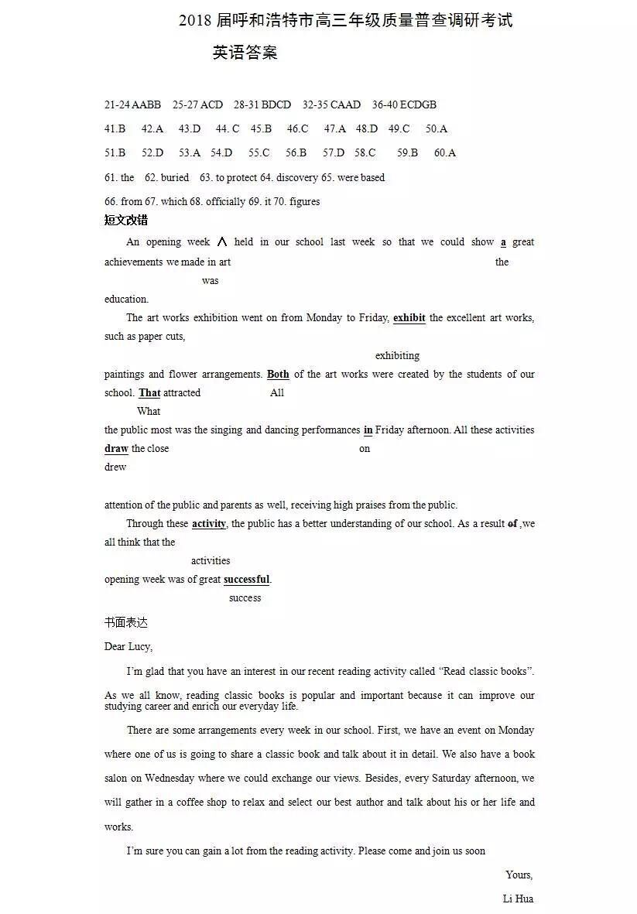

欢迎访问“高中试卷网”——http://sj.fjjy.org

