高一第一次月考
英语试题
第I卷（三部分，共70分）

第二部分：英语知识运用（共两节，满分 40分）
第一节（共15小题， 每小题2分，满分30分）
阅读下列短文，从每题所给的四个选项(A、 B、 C和D）中。选出最佳选项，并在答题卡上将该项涂黑。
A
A healthy amount of sunshine may be the secret to staying young. British scientists have discovered.
Vitamin D is produced naturally by the skin in response to(对…的反应) sunlight and may help to slow the ageing process and protect against heart disease, according to the study.
Researchers from King’ s College London studied 2,160 women aged between 18 and 79, looking at their telomeres--- a biological marker of ageing found in DNA. As people get older, their telomeres get shorter and they become more susceptible(易受伤害的) to certain illnesses.
But the study found women with high levels of vitamin D had comparatively longer telomeres--- a sign of being biologically younger and healthier.
The study suggests vitamin D may help to slow down the ageing process of DNA, and therefore the ageing process as a whole.
Lead researcher Dr Brent Richards said, “These results are exciting because they show for the first time that people who have higher levels of vitamin D may age more slowly than people with lower levels of vitamin D.” This could help to explain how vitamin D has a protective effect on many ageing related diseases, such as heart disease and cancer.”
Professor Tim Spector, a co-author of the report, added, “ Although it might sound absurd(荒唐的), it’s possible that the same sunshine which may increase our risk of skin cancer may also have a healthy effect on the general ageing process.
Vitamin D made by the action of sunlight on the skin accounts for 90 percent of the body’s supply, but lower levels can also be got through food such as fish, eggs and breakfast cereals(粥).
Other studies have suggested the vitamin plays a key role in protecting against cancer and heart disease.
21. A certain amount of sunshine helps people stay young because _________.
A. people feel happy and energetic in the sun
B. vitamin D may help to slow the ageing process
C. sunshine protects people against heart disease
D. vitamin D makes one’s skin look young and healthy
22. From Brent Richards, we know that ________.
A. sunlight causes skin cancer to people with high level of vitamin D
B. the study generally has a healthy effect on the general ageing process
C. the higher levels of vitamin D people have, the more slowly people may age
D. vitamin D can only be got from fish, eggs and breakfast cereals
23. What can we infer from the passage?
A. Sunlight does more good than harm to our health.
B. Telomeres are important as they are signs of ageing of the DNA.
C. Sunlight can be dangerous as it causes skin cancer.
D. Vitamin D can also be gained from food.
24. What is the best title of the passage?
A. Secret of Staying Young B. Sunlight and Vitamin D
C. Vitamin D Helps Slow Ageing D. Sunlight and Health

ziyuanku.comB
China is the biggest market in the world, and many countries such as Germany, the USA, the UK and Russia do a lot of business in China. Let’s have a look at some important tips to help you be successful when dealing with these nationalities.
First, you must be punctual (准时的) with Germans. Even 5 minutes late makes a bad impression. Being punctual is also very important in the USA. In the UK, it’s important to be punctual for business meetings, but nobody expects you to be on time for a social event. Half past seven really means a quarter to eight, or even eight o’clock! With Russians, you should always be on time, though it is not unusual for them to be one or even two hours late!
It is best to dress formally and wear dark colours when you meet people from all the four countries. In Russia, designer clothes are very common. Don’t be surpri if you go to an office in the UK on a Friday and find everyone wearing jeans. Many companies have “dress down Friday”, when people wear casual (随便的) clothes.
In Germany, first names are only used by family members and close friends, so be prepared to use titles and last names. In the USA you will usually be invited to use first names almost immediately. The British are quite informal and using first names in business is more and more common, especially among younger people. In Russia, however, nobody uses first names, so use titles and last names.
In conversation, the British and the Americans value humour, and both like to talk about sport. The weather is also a good topic of conversation with the British and the Americans, but avoid talking about politics. In Russia, say positive（肯定的） things about their country, but avoid making complaints. The Germans, however, prefer to get straight down to business!
So, use these tips, and you will be on your way to a successful international business career!
25. Which color should you NOT wear when meeting a person from the USA?
A. Dark blue. B. Gray. C. White. D. Black.
26. All of the following statements are true EXCEPT ______.
A. you can say something funny when you talk to an American
B. you must be on time when you meet people from each of the four countries
C. you can use his first name when you talk to an Englishman
D. people wear whatever they like on Friday in some companies in the UK
27. When you talk to a Russian, you can ______.
A. complain about something
B. say something negative about his country
C. point out some disadvantages in politics
D. say something good about his country
28. The tips in this passage are probably given to people from ______.
A. the USA B. China C. Germany D. the UK
C
Teen Art Show
Do you want to see your artwork displayed alongside other teens' artwork? Don't miss your opportunity! Showcase your paintings, sculptures, photographs and other artworks at the Environmental Educational Center. The show will provide an opportunity for artists to network, provide feedback and become a resource for others. The evening will start with light refreshments(点心) on the opening night.The top nominee will receive prizes.
Location: Environmental Educational Center
Night Fishing
Escape the night and join us as we fish at Desert Breeze Park. No experience needed. We will provide the fishing poles, transportation, the bait, help you catch a fish and best of all, teens 14 years and under do not require a license to fish.
Location: Desert Breeze Park
Depart from: Downtown Community Center
Resident fee: $ 2
Nonresident fee: $ 3
Overnight Snow Trip
Join the City of Chandler in an exciting new trip! We will travel up to Camp Tontozona and spend the night in lodges that overlook the snowcovered forest and nearby stream. We will enjoy great food and a campfire in the early evening. Snow play will be the highlight as we explore the snowfilled meadows(草地) of Woods Canyon Lake and sled down small hills in the area.
Please make sure a valid email is used upon registration to receive additional information about this trip.
Location: Camp Tontozona
Resident fee: $ 30
Ziyuanku.comNonresident fee: $ 41
Paintball
Come out and play paintball with all your friends! Join the City of Chandler as we go to Tempe Indoor Paintball. This is a great way to join in the fun of playing paintball for a low, low cost. All equipment is included. Please wear old clothes because clothes can get dirty easily! Please ensure correct email is on registration form to receive waiver (弃权声明)．
Location: Tempe Paintball
Depart from: Downtown Community Center
Resident fee: $ 28
Nonresident fee: $ 36
29. We can infer that Teen Art Show________.
中华资源库A. will be held outdoors
B. is a little competitive
C. will cost the participants much money
D. will offer winners light refreshments
30. What should you do to play paintball?
A. To wear old dirty clothes.
B. To pay $ 64 for the equipment.
C. To write your email right on the form.
D. To go to Desert Breeze Park.
31. If you join in Overnight Snow Trip, you will________.
A. live in the snowcovered forest
B. ski on Woods Canyon Lake
C. barbecue your food on a campfire
D. play with snow on small hills

来源：www.ziyuanku.comD
Internet shopping is a new way of shopping.Nowadays，you can shop for just about anything from your armchair.Shopping on the Internet is becoming increasingly popular.
People can shop for a variety of products on the Internet.Physical products include items such as books，CDs，clothes and foods.These types of products are the most common purchases through the Internet.To find something on the Internet, people often use powerful computer tools called “search engines”．You can search for a type of product such as sports shoes，or a brand name, such as Nike.The search engine will give you a list of websites where you can find these products.These websites may be specialist shops such as a Nike shop，or they may be general stores，called malls，which sell a variety of goods.
Internet shopping offers a number of benefits for the shopper.The most important advantage is convenience.As the online shops are open 24 hours a day，you don't have to queue with other shoppers at the checkout counters.Secondly，it is easy to find what you are looking for on the Internet.Finally，it is often cheaper to buy goods through the Internet.
The main disadvantage of Internet shopping is that you cannot actually see the products you are buying or check their quality.Also，many people enjoy shopping in the city and miss the opportunity to talk to friends.Some people are worried about paying for goods using credit cards，so Internet companies are now finding ways to make online payment safe.
Internet shopping is sure to become more and more popular in the years ahead.It promises to change the way we buy all kinds of things from tonight's dinner to a new car.
32．The first paragraph indicates(表明) that ________.

A．there are many problems with online shopping
B．online shopping is becoming very popular
C．people hate online shopping in cities
D．it is very inconvenient for online shopping
33．From the second paragraph，we know the underlined word “malls” means ________.
A．stores where we can buy famous brand (牌) products
B．places where people can receive better service
C．specialist shops
D．stores which sell many kinds of goods
34．Internet shopping can offer shoppers the following benefits EXCEPT ________.
A．online payment safety
B．the speed the goods are delivered at
C．the reasonable price
D．the convenience it brings to you
35．According to the passage，we can infer that ________.
A．since it is not safe to pay online，Internet shopping will disappear in the years ahead
B．it will become the only way we buy things in the years ahead
C．there is no disadvantage of Internet shopping
D．it'll change the way we buy things
中华资源库第二节（共5小题；每小题2分，满分10分）
根据短文内容，从短文后的选项中选出能填入空白处的最佳选项。选项中有两项为多余选项。
Taking good notes is a time-saving skill that will help you to become a better student in several ways____36_____.Second, your notes are excellent materials to refer to when you are studying for a test. Third, note-taking offers variety to your study time and helps you to hold your interest.
You will want to take notes during classroom discussions and while reading a textbook or doing research for a report. ____37_____Whenever or however you take notes, keep in mind that note-taking is a selective process. _____38____
The following methods may work best for you.
●Read the text quickly to find the main facts and ideas in it.
●Carefully read the text and watch for words that can show main points and
supporting facts.
● Write your notes in your own words.
● ____39_____
● Note any questions or ideas you may have about what was said or written.
As you take notes, you may want to use your own shorthand(速记). When you do, be sure that you understand your symbols(符号) and that you use them all the time. ____40_____
A．Use words, not complete sentences.
B．There are three practical note-taking methods.
C．You must write your notes on separate paper.
D．Otherwise, you may not be able to read your notes late
E. you will also want to develop your own method for taking notes.
F. That means you must first decide what is important enough to include in your notes.
G. First, the simple act of writing something down makes it easier for you to understand and remember it.
第三部分 英语知识运用(共两节，满分45分)
第一节 完形填空(共20小题；每小题1.5分，满分30分)
阅读下面短文，从短文后各题所给的四个选项(A、B、C和D)中，选出可以填入空白处的最佳选项。
On Mother's Day one woman called her mother to wish her a happy Mother's Day—800 miles __41__ her from her parents in Ohio.Her mother had mentioned purple lilacs (丁香) __42__ on the big bush outside their back door. As they talked, the __43__ woman seemed almost to smell the fragrance(芬芳)．
Later, when she mentioned to her husband __44__ she missed those lilacs, he got up from his chair. “I know where we can find __45__ you want，” he said.
So off they went，__46__ on country roads of northern Rhode Island on the very sunny day. Soon they got to the hill where large bushes of __47__ lilacs grew vigorously around a deserted well. With a smile, the young woman __48__ to the nearest bush and __49__ her face in the flowers, drinking in the fragrance and the __50__ it recalled. Carefully, she picked up a large bunch of lilacs with her husband's pocket knife.
Finally they __51__ home. When they were within three miles of home, she _52__ asked her husband to stop the car.The woman was seen _53__ a nearby hill with the lilacs still in her arms. At the top of the hill was a nursing home __54__ an elderly patient was sitting in her wheelchair, alone, head bowed. The young woman placed the __55__ into the lap of the old woman.She lifted her head and smiled.For a few __56__， the two women chatted, both aglow (容光焕发的)with happiness, and __57__ the young woman ran back to her husband.As the car __58__，the woman in the wheelchair waved with the flowers.
When her husband __59__ the young woman why she did that, she said that it was Mother's Day and that old woman needed those flowers _60__ than she did.
41．A.divided B．separated
C．removed D．spared
42．A.falling B．providing
C．covering D．hanging
43．A.younger B．worried
C．older D．concerned
44．A.why B．what
C．how D．which
45．A.any B．all
C．both D．each
46．A.passing B．leaving

C．coming D．driving
47．A.yellow B．red
C．purple D．pink
48．A.rushed up B．looked out
C．watched over D．calmed down
49．A.made B．raised
C．buried D．turned
50．A.stories B．memories
C．expressions D．favorites
51．A.wandered B．returned
C．pulled D．sent
52．A.immediately B．generally
C．quietly D．suddenly
53．A.running down B．stepping onto
C．pushing against D．hurrying up
54．A.when B．because
C．where D．though
55．A.flowers B．hands
C．head D．money
56．A.moments B．words
C．suggestions D．greetings
57．A.thus B．then
C．soon D．also
58．A.drove aside B．broke down
C．pulled away D．came along
59．A.asked B．complained
C．ordered D．thanked
60．A.less B．rather
C．larger D．more

第Ⅱ卷 (非选择题，共50分)
第三部分 英语知识运用(共两节，满分45分)
第二节(共10小题；每小题1.5分，满分15分)
阅读下面材料，在空白处填入适当的内容(1个单词)或括号内单词的正确形式。
When I failed in the final exam, I almost lost heart. My teacher told me a quote , 61 goes like this; “Your future depends on many things, 62 mostly on you. ” I can't agree 63 (much) with this view. It's true that our future 64 (determine) by many things, such as opportunities and help from others, but our own attitude, determination, 65 hard work play a more important role. In 66 words, we are the master of our own future.
Take Abraham Lincoln for example. He was born in a poor family, and only received a 67 (limit) education in his childhood. Yet through his painstaking efforts, he changed not only his own fate but also the history of America. 68 to this day. Lincoln 69 (regard) as one of the most inspiring figures in the world. 70 , I firmly believe that our future is in our own hands.
第四部分 写作(共两节，满分35分)
第一节 短文改错(共10小题；每小题1分，满分10分)
假定英语课上老师要求同桌之间交换修改作文，请你修改你同桌写的以下作文。文中共有10处语言错误，每句中最多有两处。每处错误仅涉及一个单词的增加、删除或修改。
增加：在缺词处加一个漏字符号(∧)，并在其下面写出该加的词。
删除：把多余的词用斜线(\)划掉。
修改：在错的词下画一横线，并在该词下面写出修改后的词。
注意：1. 每处错误及其修改均仅限一词；
2. 只允许修改10处，多者(从第11处起)不计分。
There was a blind girl which hated herself just because she was blind. She hated everyone besides her loving boyfriend. He was always there for her. She said that if she could see the world, she would marry with her boyfriend. One day, someone donated pair of eyes to him and then she could see everything, including her boyfriend. Her boyfriend asked her, “Now that you can't see the world, will you marry me？” The girl was shocking when she saw that her boyfriend was blind either, and refused to marry him. Her boyfriend walked away in tears, but later wrote a letter to her said: “Just take care of my eyes.”

第二节 书面表达(满分25分)
每当大型考试来临时，很多同学都会表现出不同程度的紧张，请以此为题写篇词数不少于120的短文，谈谈你对如何缓解考试焦虑情绪的见解。
写作要点：
1．考试焦虑的危害；
2．你的见解：
*正确认识考试，制定科学的学习计划；
*保持良好的心态，适量运动，听音乐等；
*保持充足的睡眠和均衡的饮食。
注意：1.文章标题已给出，不计入总词数；
2.可适当补充内容。
参考词汇：nervousness紧张 have an...attitude towards...对……有……的态度
How to Relax before Exams
________________________________________________________________________
________________________________________________________________________
________________________________________________________________________
________________________________________________________________________
________________________________________________________________________
________________________________________________________________________
________________________________________________________________________
________________________________________________________________________
________________________________________________________________________
________________________________________________________________________
________________________________________________________________________
________________________________________________________________________
________________________________________________________________________
________________________________________________________________________
________________________________________________________________________
________________________________________________________________________
________________________________________________________________________
________________________________________________________________________
________________________________________________________________________
________________________________________________________________________
________________________________________________________________________

参考答案
阅读理解：A篇：BCAC B篇：CBDB C篇：BCD D篇：BDAD
七选五：36----40 GEFAD
完形填空：41—45 BDACB 46—50 DCACB 51—55 BDDCA 56—60 ABCAD
语法填空答案
56. which 57. but 58. more 59. is determined 60. and
61. other 62. limited 63. Even 64. is regarded 65. Therefore
答案：
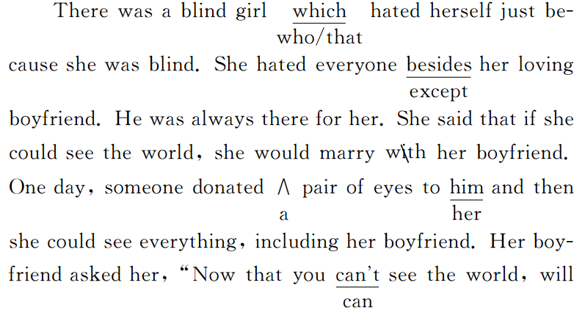
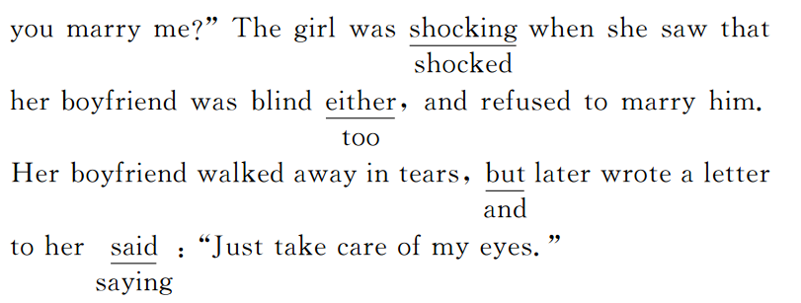
第二节 书面表达(满分25分)
How to Relax before Exams
Many of us feel somehow nervous whenever we are taking an important exam. Nervousness not only does harm to students' health but also disturb our study. So it's necessary for us students to learn to relax. I think it's very important to have a right attitude towards exams. Exams are only a means of checking what we have learned. Therefore, there is no need to worry too much about the results. Before an exam, making a scientific study plan and keeping a peaceful mind can help to reduce the pressure from the exams. We can also relax ourselves by doing sports and listening to music. Besides, enough sleep and a balanced diet will work as well.
Follow my advice and you will enjoy your school life.

